Use Cases For Game Design
Team : Direct Workflow
Game Name : TBD

Use Case Actors
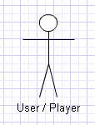

Use Case Actor Goals
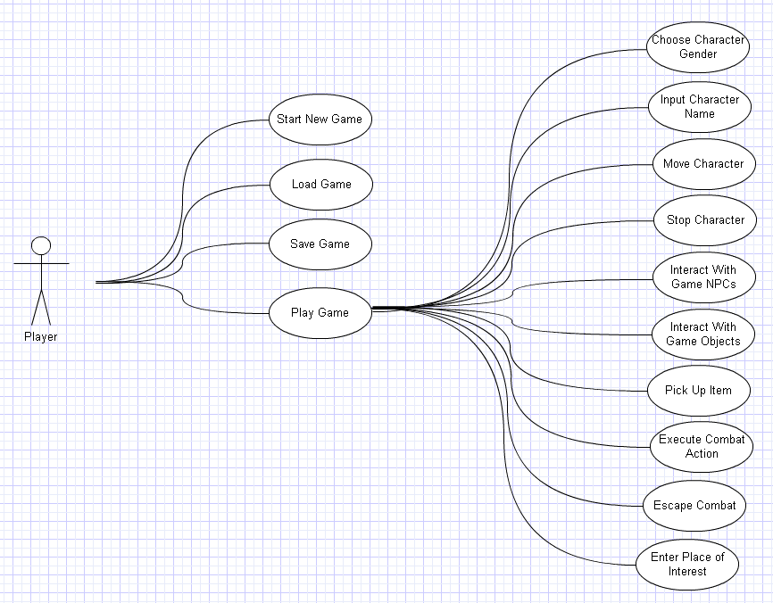
Use Case Index
Use Case ID | Use Case Name | Primary Actor
1 | Start New Game | Player
2 | Load Game | Player
3 | Save Game | Player
4.1 | Choose Character Gender | Player
4.2 | Input Character Name | Player
4.3 | Move Character | Player
4.4 | Stop Character | Player
4.5 | Interact With Game NPCs | Player
4.6 | Interact With Game Objects | Player
4.7 | Pick Up Item | Player
4.8 | Execute Combat Action | Player
4.9 | Escape Combat | Player
4.10 | Enter Place of Interest | Player

Complete Use Case Descriptions with Preconditions, Trigger, Basic Flow and Alternate Flows

Use Case Element | Description
Use Case Number | 1
Application | Game System
Use Case Name | Start New Game
Use Case Description | The player wishes to play the game from the start. This starts the game from the very beginning not regarding any previous play time.
Primary Actor | Player
Precondition | Game Program is running.  Main Game Menu is open.
Trigger | Player Decision
Basic Flow | Closes Main Menu then a new Game Campaign starts.
Alternate Flows | N/A

Use Case Element | Description
Use Case Number | 2
Application | Game System
Use Case Name | Load Game
Use Case Description | Player starts the game program but wants to play from the last saved point progress. This transports the player to the exact point in the game where he saved his progress.
Primary Actor | Player
Precondition | Player has an existing saved point.  Main Menu is open.
Trigger | Player Decision
Basic Flow | Leaves Main Menu then loads the player's saved point.
Alternate Flows | Error message pops up because the Saved Point File is corrupted or inaccessible.

Use Case Element | Description
Use Case Number | 3
Application | Game System
Use Case Name | Save Game
Use Case Description | Player wants to save all the progress he's made in the game. This creates a saved point in the game where he can access later through the "Load Game" function.
Primary Actor | Player
Precondition | Player is in the middle of a game session.  Player has enough save memory available.  Player has access to a save point marker.
Trigger | When player interacts with a Save Point Marker in the game world.
Basic Flow | Game Progress is saved in file then the Player resumes his gameplay.
Alternate Flows | Player is prompted when there is not enough save memory left.

Use Case Element | Description
Use Case Number | 4.1
Application | Game System
Use Case Name | Choose Character Gender
Use Case Description | As the game starts, the player is asked which gender he/she wants their character to be. Player chooses preferred gender for character.
Primary Actor | Player
Precondition | New Game is started.
Trigger | When Player starts a new game.
Basic Flow | Game accepts player's choice, applies gender preference on the character, then resumes with the gameplay.
Alternate Flows | N/A

Use Case Element | Description
Use Case Number | 4.2
Application | Game System
Use Case Name | Input Character Name
Use Case Description | While creating a new character for a new game, the player is asked to name his newly created character.
Primary Actor | Player
Precondition | New game is started
Trigger | When player starts a new game.
Basic Flow | Game accepts player's input, changes character name to the assigned name then resumes with the gameplay
Alternate Flows | Game reprompts the player for a name because either the name exceeded the allowed number of letters or invalid characters were used for the name.

Use Case Element | Description
Use Case Number | 4.3
Application | Game System
Use Case Name | Move Character
Use Case Description | Player uses directional arrow keys (or binded keys) to make the game character move around the game world.
Primary Actor | Player
Precondition | Game is active.  Player character is in the game world and not in combat or menus.
Trigger | When the player needs to go to any place in the game world.
Basic Flow | Character animation starts and the character moves according to the direction specified by the user.
Alternate Flows | An object is blocking the path that the player wants to move to. The character remains in the same spot unless he chooses to move in another direction.

Use Case Element | Description
Use Case Number | 4.4
Application | Game System
Use Case Name | Stop Character
Use Case Description | While moving, a player wants to stop movement to remain at a desired point on the map.
Primary Actor | Player
Precondition | Player character is moving in a specific direction.
Trigger | When player wants to stop moving and remain at a certain spot.
Basic Flow | Movement animation stops. Character stays at the same spot.
Alternate Flows | N/A

Use Case Element | Description
Use Case Number | 4.5
Application | Game System
Use Case Name | Interact with Game NPCs (non-player characters).
Use Case Description | Player interacts with in-game Characters to access certain game functions like vendors, conversation options or to progress the game's story and development.
Primary Actor | Player
Precondition | Player character must be in the game world standing next to an NPC while facing its direction.
Trigger | When player wants to access certain game functions like vendors, conversation options or to progress the game's story and development (those of which can only be achieved by interacting with such NPCs).
Basic Flow | NPC acknowledges interaction and responds with programmed response (open vendor shop, progress the story or speak a game related line)
Alternate Flows | *NPC is not programmed to provide interaction for players so nothing happens.  *The player character hasn't met the requirements (level requirement or quest completion) to invoke a certain NPC response so nothing happens.

Use Case Element | Description
Use Case Number | 4.6
Application | Game System
Use Case Name | Interact with Game Objects
Use Case Description | Player wants to use or interact with objects in the game world like switches or levers to advance the game's story and progression.
Primary Actor | Player
Precondition | Player character must be in the game world standing next to an object while facing its direction.
Trigger | When the player wants to use or interact with objects in the game world like switches or levers to advance the game's story and progression.
Basic Flow | The object function is achieved. (Door opens / closes etc..)
Alternate Flows | *Object is not programmed to provide interaction for players so nothing happens.  *The player character hasn't met the requirements (level requirement or quest completion) to invoke a certain object response so nothing happens.

Use Case Element | Description
Use Case Number | 4.7
Application | Game System
Use Case Name | Pick Up Item
Use Case Description | Player character wants to pick up an item laying around in the game world. He picks the item up and stores it in his bag/inventory.
Primary Actor | Player
Precondition | Player character must be in the game world standing next to the item while facing its direction.  Player must have enough space in his bag or inventory for the item to be stored.
Trigger | When player character wants to pick up an item laying around in the game world. He picks the item up and stores it in his bag/inventory.
Basic Flow | The item disappears from the ground and is stored in the player character's bag or inventory for future use.
Alternate Flows | The game prompts the player that his bag/inventory doesn't have enough space for the item to be stored. The items remain in the ground.

Use Case Element | Description
Use Case Number | 4.8
Application | Game System
Use Case Name | Execute Combat Action
Use Case Description | While in combat, a player wants to execute any of the available skills that he/she has to either deal damage to the enemy, use items, or buff their characters.
Primary Actor | Player
Precondition | Player character needs to be in combat with any enemy in-game.
Trigger | Combat is randomly generated based on the level and the zone that the player character is in. Combat needs to be won by executing combat actions.
Basic Flow | Player chooses appropriate action to execute in combat. The character executes the command and deals the appropriate effects.
Alternate Flows | The player character doesn't have enough resources (Mana or items) to execute the command. The Game prompts the shortage in resources. Nothing is executed.

Use Case Element | Description
Use Case Number | 4.9
Application | Game System
Use Case Name | Escape Combat
Use Case Description | A player wants to avoid combat . The player can choose to run away from the random combat encounters.
Primary Actor | Player
Precondition | Player character needs to be in combat.
Trigger | Player wants to avoid combat.
Basic Flow | Player chooses "Escape Combat" option. Combat ends with no rewards. Player character is back to the same point in the world map before he encountered combat.
Alternate Flows | Certain Game Bosses are not possible to run away from. Escape will fail to execute. Player character will remain in combat.

Use Case Element | Description
Use Case Number | 4.10
Application | Game System
Use Case Name | Enter Place of interest
Use Case Description | Certain places in the game can only be accessed by entering "points" in the map. Player moves into such points to enter caves, houses, basements etc.
Primary Actor | Player
Precondition | Place of Interest is within reach of the player character.
Trigger | When player wants to enter such places to advance gameplay.
Basic Flow | Player character enters place of interest. The game world is changed to match the inside of the place entered.
Alternate Flows | The player character doesn't meet the requirements (level or quest completion) to enter such places. The game prompts the player that he/she doesn't meet the requirements to enter.

